### **Roses are Red, Violets are Blue, I Would Love a Heart Sliceform, How About You?**

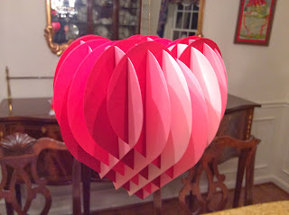

Sliceform Heart

Of course you would, if you are reading this post. I know there are other versions of this heart sliceform online but I wanted to make my own version with more slices and more definition. When looking at the top of the heart, you can actually see the four lobes of the heart. Did you ever wonder why a heart is called a heart? Well, here is the reason, the four lobes of a 3D heart represent the four chambers of a human heart. I also needed to make this version for my next project which is a heart snow globe. So, look for it in the upcoming weeks.

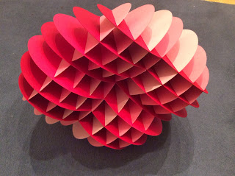

You can see the four lobes of the heart. The heart is a little skewed because it is hard to get a good picture while it is lying on its side.

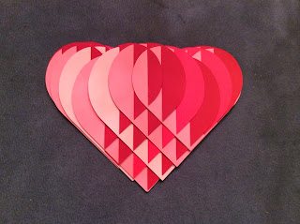

Here is the sliceform heart lying flat on a surface. I love the little triangles that are formed when closed.



An animated look of the sliceform heart hanging from my chandelier.